May 06, 2015

LA-10, Vasco Digipass Password Settings:

VascoID Password Policy:

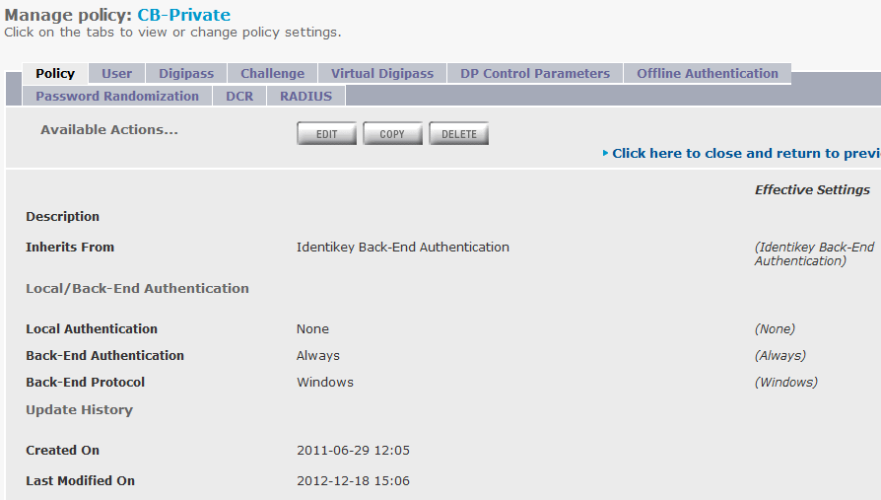

Windows Password Policy:

